Lesson 6 Homework

1. Refer to HOCKEY data. Write a SAS program which calculates the number of games won, lost, and tied up to and including the current observation. Print the dataset with an appropriate format for the date. Don’t forget to change the score of the final game to Boston College 5, Ohio State 2 (do this in your code, don’t change the original file). The first few lines of output should be similar to this:

DATE TEAM CITY STATE OSU OPP W L T

10/10/97 Toronto Columbus Ohio 5 0 1 0 0

10/18/97 Miami Oxford Ohio 0 3 1 1 0

10/24/97 Merrimack Columbus Ohio 2 7 1 2 0

10/26/97 Merrimack Columbus Ohio 5 3 2 2 0

10/31/97 Clarkson Potsdam New York 1 1 2 2 1

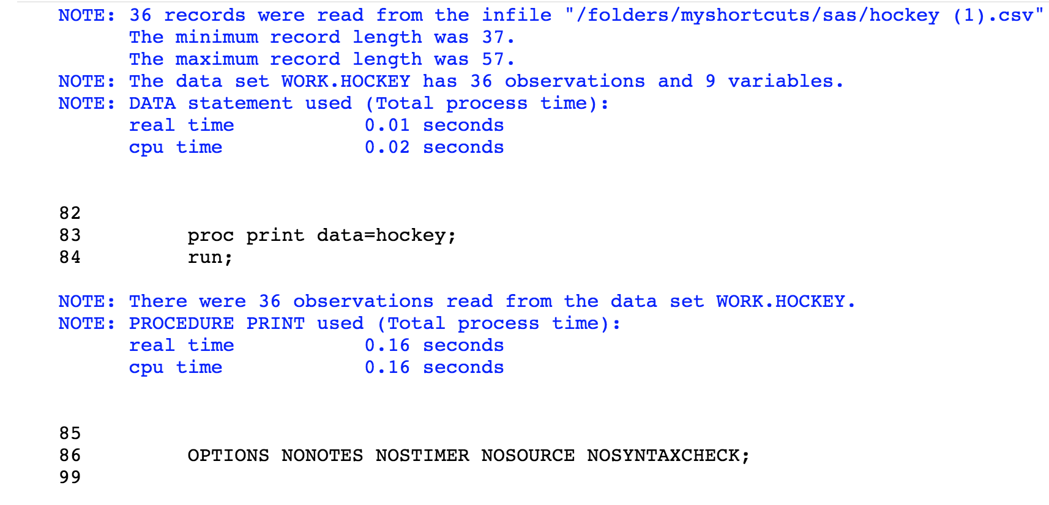

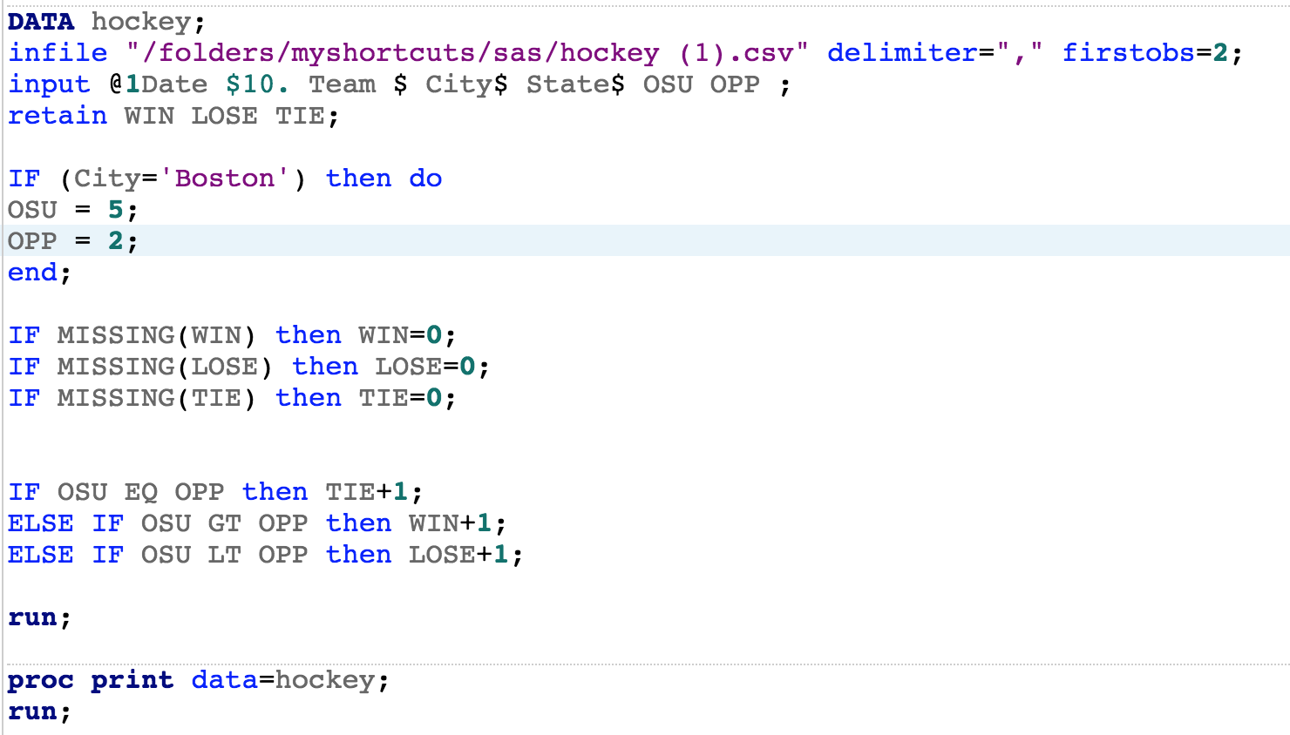

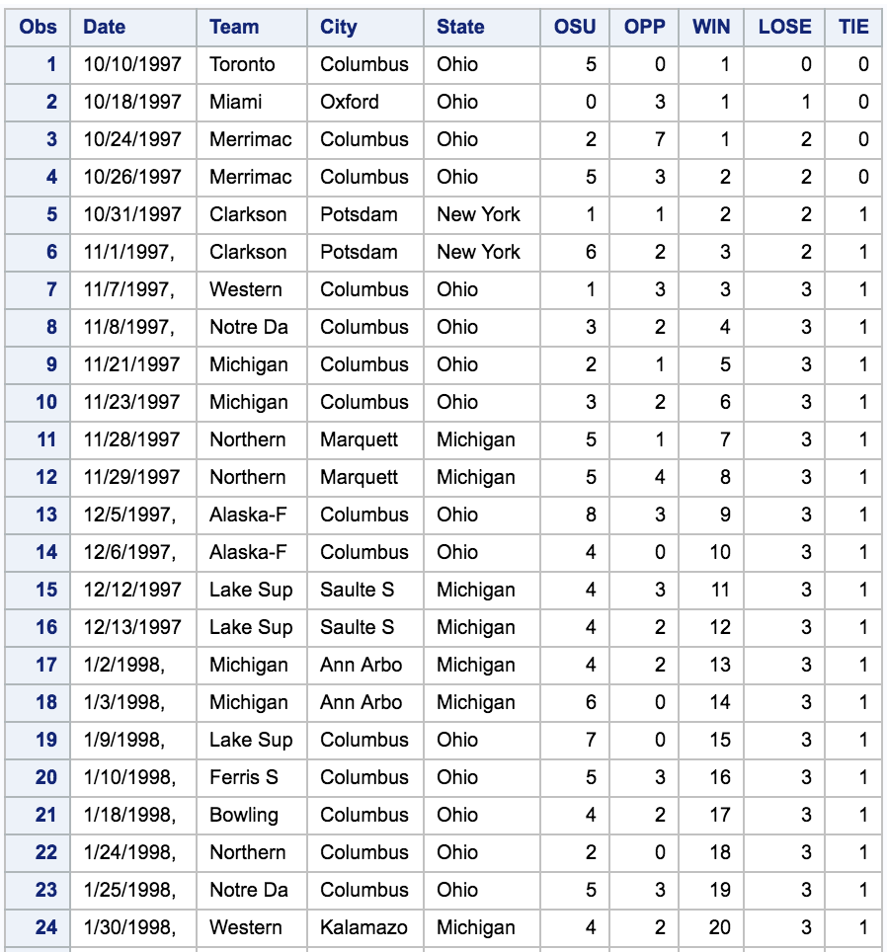

2. Suppose that your 5th grader is learning how to write Roman numerals, and you want to help her or him by preparing a study guide. Write a SAS program which uses DO loop to print the Arabic numbers 1, 2, 3, …,49, 50 AND their Roman equivalents. The ROMAN7. format in SAS will be helpful.

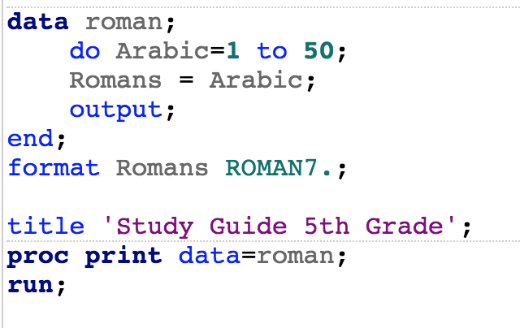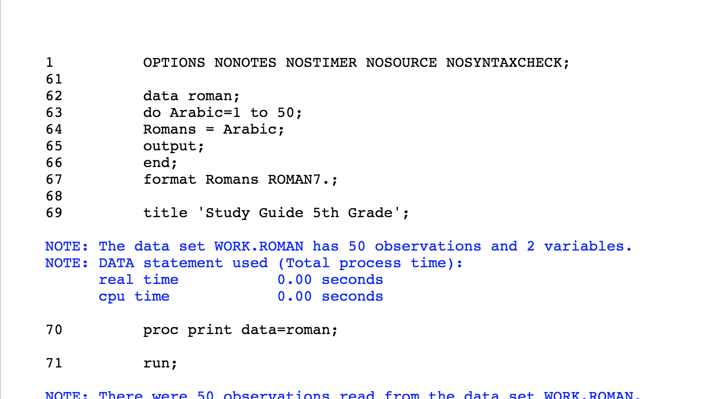

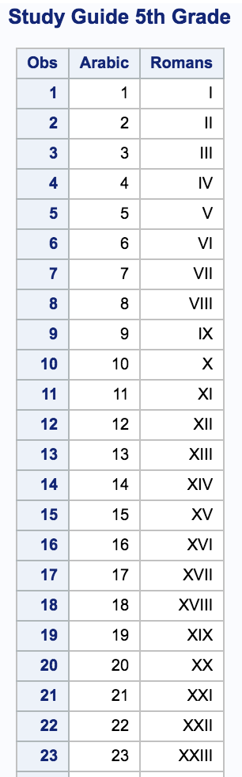

3. Refer to the DOGS3 data. Write a SAS program which creates a dataset using the INFILE statement. Then, create a new dataset which contains three variables: the name of the dog, the week of the measurement, and the eosinophil count in that week. There should be 75 observations in the new dataset. Print both datasets.

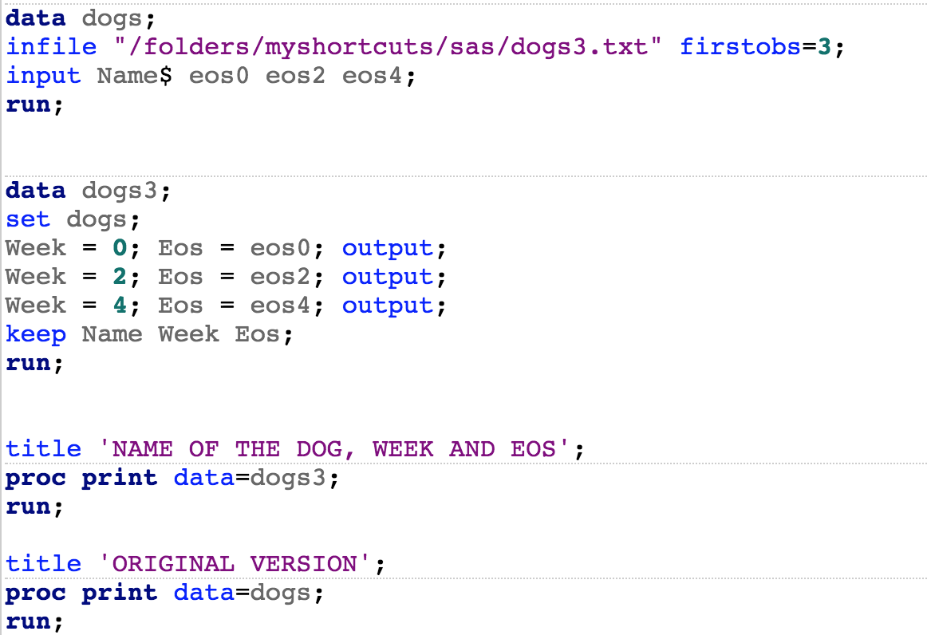

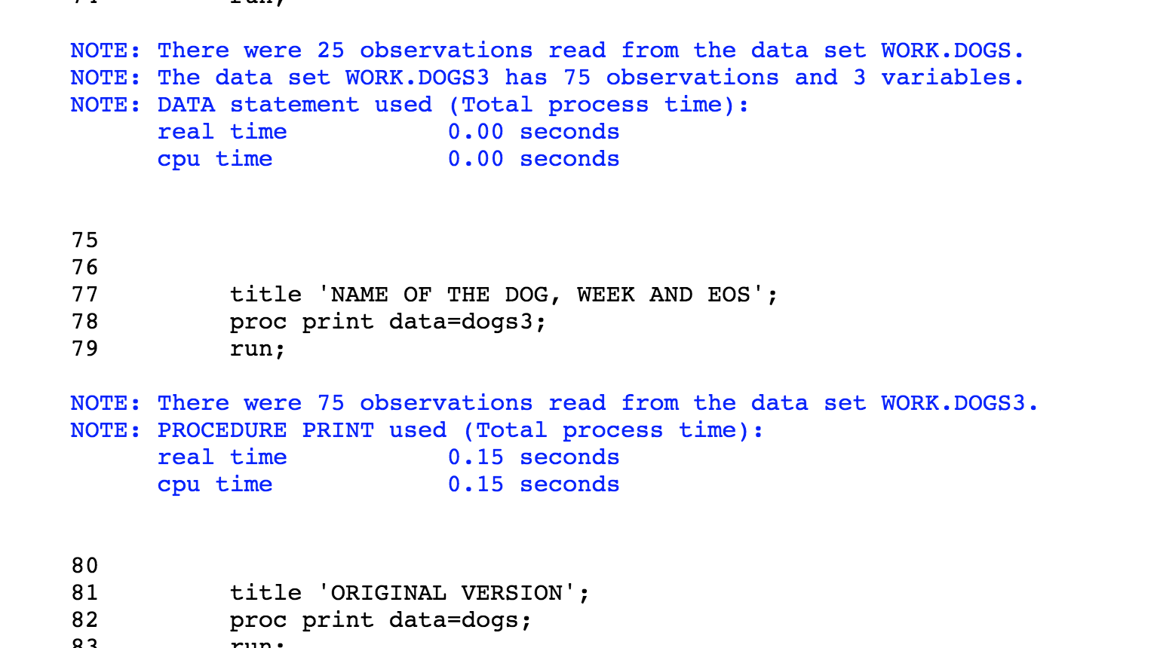

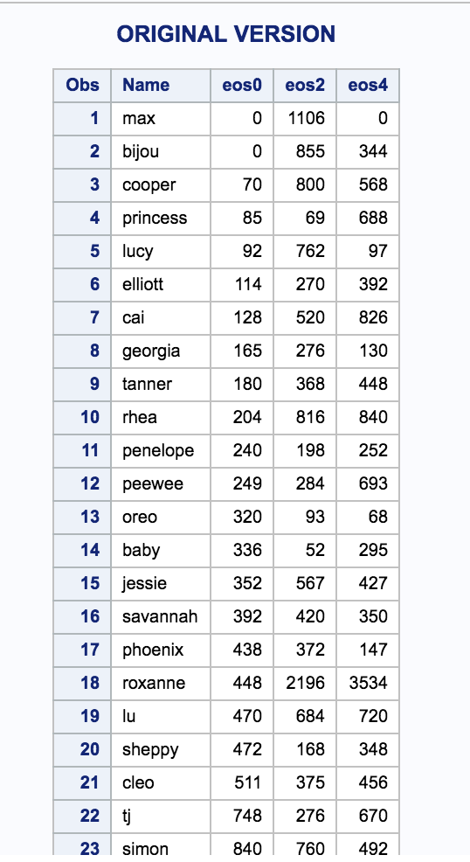

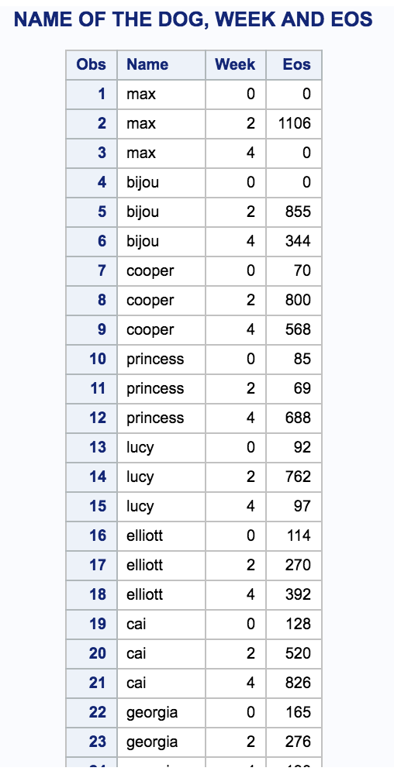

4. Refer to the RYAN data. Many of the ratings are missing. Suppose that a statistician wants to perform a procedure which does not allow missing values. He decides that one acceptable way to do the analysis is to replace each missing rating with the neutral rating (5). Write a SAS program which uses an array to replace all of the missing values for movie ratings with scores of five. Print the corrected dataset.

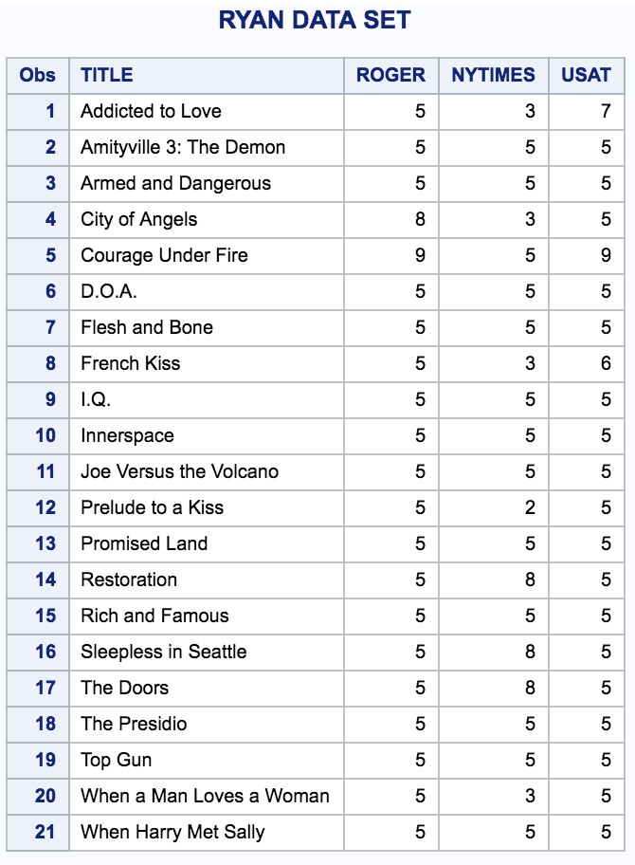

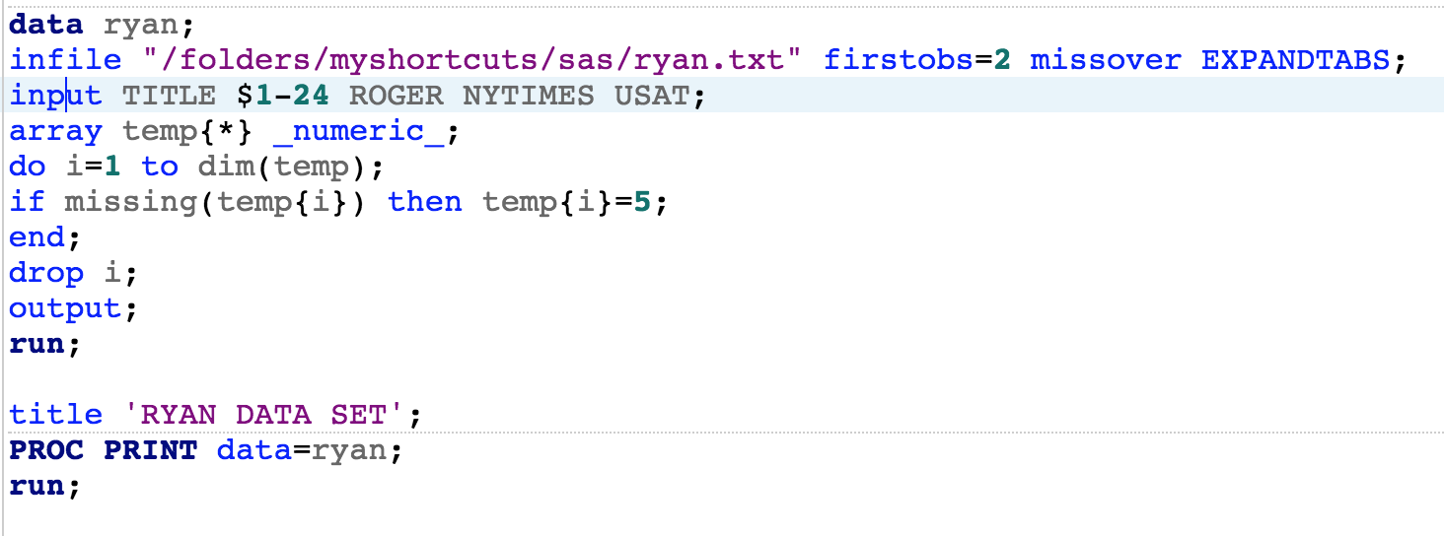

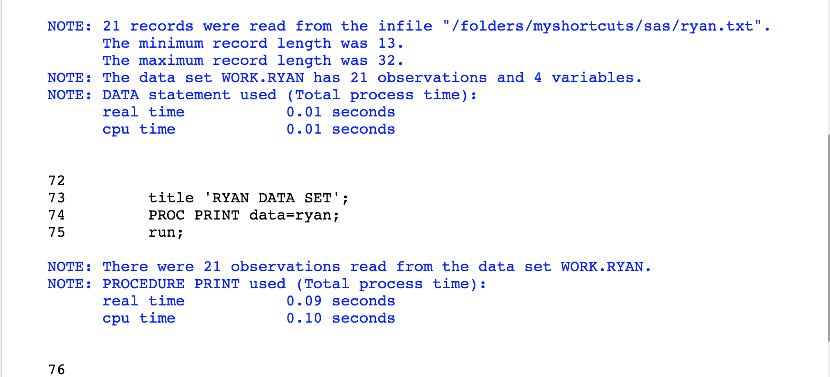

5. The passing score on each of five tests is 65, 70, 60, 62, and 68. Using the data here, use a temporary array to count the number of tests passed by each student.

